Plasmid replication by strand-displacement mechanism
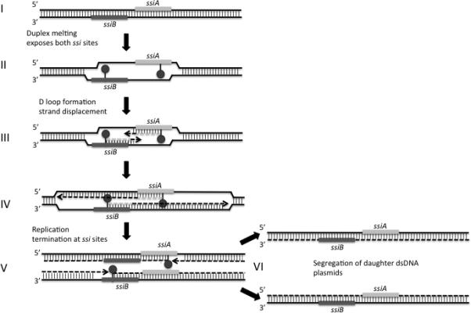
Model of plasmid replication by the strand-displacement mechanism.
- Parental DNA duplex (solid black lines) depicting the two single-stranded replication initiation sites, ssiA (light gray box) and ssiB (dark gray box). Vertical lines show hybridization between DNA strands.
- The DNA duplex is melted through binding of RepC (possibly in concert with the RepA helicase), allowing the two ssi sites to form hairpins (ball and stick).
- The base of the hairpin is recognized by RepB’, which initiates the synthesis of an RNA primer (light grey dashed line). Extension of the free 3’-OH of the primer by Pol III (assisted by the RepA helicase) is shown as dashed, black arrows. Two D-loops are formed, one for each direction of synthesis, as parental strands are displaced and dissociate from each other leaving ssDNA intermediates. This is shown as areas where one of the strands has no hydrogen bonding.
- Synthesis continues in both directions, extending the area of D-loop formation.
- Elongation is completed and termination of replication occurs on both strands at the ssi sites in which replication began. At this point, the ssi sites on the newly synthesized daughter strands are restored.
- Segregation: the two daughter strands are ligated, resulting in two DNA duplexes, each containing a parental strand (solid black line) and daughter strand (dashed black line).

